SIMATS ENGINEERING
ASSESSMENT TOOL 3

COURSE NAME: Database Management Systems
COURSE CODE: CSA05

COURSE OUTCOME COVERED

CO2: Apply the relational model, relational algebra, SQL query structures, and views to solve database querying and data manipulation problems. (BL3, BL6)

Activity Tool : Debugging & Optimisation Task (Low)
Assessment Tool Weightage: 10%

QUESTIONS
Q.No | Question | Bloom's Level
1 | Identify and correct errors in a given SQL CREATE TABLE statement with incorrect syntax and missing constraints. | BL2 – Understand
2 | Debug an SQL query that incorrectly uses aggregate functions without GROUP BY and fix the issue. Bloom’s Level: | BL2 – Understand
3 | Correct a faulty SELECT query where column names are misspelled or improperly referenced. | BL1 – Remember
4 | Fix errors in an SQL query using JOIN, where the join condition is missing or incorrect. | BL3 – Apply
5 | Identify and correct a subquery error where multiple values are returned instead of a single value. | BL2 – Understand
6 | Debug a VIEW creation statement that contains invalid column references or syntax errors. | BL1 – Remember
7 | Examine an SQL query with unnecessary conditions and optimize it by simplifying the WHERE clause. | BL3 – Apply
8 | Identify violations of integrity constraints in a given table and correct them. | BL2 – Understand
9 | Fix a relation that violates 1NF or 2NF by removing repeating groups or partial dependencies. | BL3 – Apply
10 | Identify redundant attributes in a relation and apply basic normalization (up to 3NF) to improve design. | BL3 – Apply

Code of Conduct:

I DEEPTHI KORRAPATI(192572012) (Name / Reg No) certify that this submission is my original work and that I have adhered to the guidelines specified for this assessment.
I understand that any violation of academic integrity rules will result in disciplinary action.

Signature of the student:

RUBRICS FOR CALCULATION:

Criteria | Level 4 (Exemplary) | Level 3 (Proficient) | Level 2 (Developing) | Level 1 (Beginning)
Problem Identification | Accurately identifies all errors and root causes with clear understanding | Identifies most errors with minor gaps | Identifies some errors but misses key issues | Unable to identify errors correctly
Debugging | Applies systematic debugging techniques effectively to resolve issues | Uses appropriate debugging methods with minor errors | Limited debugging approach; requires guidance | Unable to debug or resolve issues
Optimization | Optimizes code by significantly improving time complexity using efficient algorithms | Improves time complexity with minor gaps in efficiency | Limited improvement in time complexity | No improvement; inefficient approach retained
Analysis | Demonstrates strong logical reasoning and clear justification of solutions | Shows reasonable analysis with some justification | Limited analysis; weak reasoning | No analytical reasoning demonstrated
Code Quality | Produces clean, well-structured code with proper comments and documentation | Code is mostly clear with minor documentation gaps | Code lacks structure and proper documentation | Poorly written code with no documentation
Q1. Identify and correct errors in a given SQL CREATE TABLE statement with incorrect syntax and missing constraints.

1. Introduction
The CREATE TABLE statement is one of the most important SQL Data Definition Language (DDL) commands. It is used to create a new table in a database by defining the table name, columns, data types, and constraints. A properly designed table ensures data accuracy, integrity, and consistency.
Errors in a CREATE TABLE statement may prevent the table from being created or may result in an improperly designed database. Therefore, identifying and correcting syntax and constraint errors is an essential SQL debugging skill.

Definition of CREATE TABLE
The CREATE TABLE command is used to create a new table in a relational database.
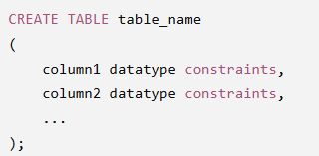

3. Importance of Constraints
Constraints ensure that only valid data is stored in the table.
Common Constraints:
- PRIMARY KEY
- FOREIGN KEY
- NOT NULL
- UNIQUE
- CHECK
- DEFAULT

4. Incorrect SQL Statement
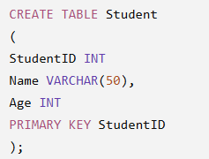

5. Error Identification
Error 1
Missing comma after StudentID.
Incorrect:

Correct:


Error 2
Missing comma after Age.
Incorrect:
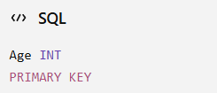
Correct:
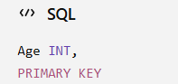

Error 3
Incorrect PRIMARY KEY syntax.
Incorrect:
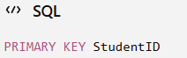
Correct:
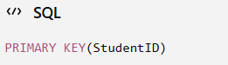

Error 4
StudentID should be NOT NULL because it is the primary key.
Correct:
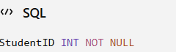

6. Correct SQL Statement
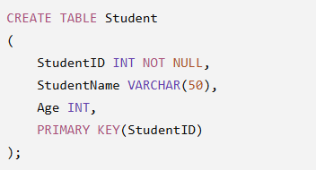
StudentID INT NOT NULL
- Integer datatype.
- Cannot contain NULL values.
- Used to uniquely identify each student.
StudentName VARCHAR(50)
- Stores student name.
- Maximum 50 characters.
Age INT
- Stores student's age.
PRIMARY KEY(StudentID)
- Ensures uniqueness.
- Does not allow duplicate values.
- Does not allow NULL values.

8. Sample Table Structure
StudentID | StudentName | Age
101 | Ravi | 20
102 | Priya | 21
103 | Kiran | 22

9. Execution Result

10. Advantages of Constraints
- Maintains data integrity.
- Prevents duplicate records.
- Prevents NULL values in important columns.
- Improves database consistency.
- Makes relationships easier.

11. Applications
- College Management System
- Hospital Database
- Banking System
- Employee Management
- Railway Reservation
- Library Management

12. Common Mistakes
- Missing commas.
- Wrong datatype.
- Incorrect constraint syntax.
- Duplicate column names.
- Missing PRIMARY KEY.

14. Conclusion
The CREATE TABLE statement is the foundation of database design. Correct syntax, proper datatypes, and appropriate constraints ensure reliable and consistent data storage. Debugging CREATE TABLE statements improves SQL programming skills and helps create efficient databases.

Q2. Debug an SQL Query that Incorrectly Uses Aggregate Functions Without GROUP BY

1. Introduction
Aggregate functions perform calculations on multiple rows and return a single result. When aggregate functions are used with normal columns, SQL requires the GROUP BY clause to group similar records.
Without GROUP BY, SQL generates an error because it cannot determine how to group non-aggregated columns.

2. Aggregate Functions
Common aggregate functions include:
- COUNT()
- SUM()
- AVG()
- MAX()
- MIN()

3. GROUP BY Definition
GROUP BY divides rows into groups so aggregate functions can calculate results for each group separately.

4. Incorrect Query
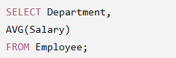

5. Error
Department is a normal column.
AVG() is an aggregate function.
SQL does not know how to calculate the average salary for each department.

6. Correct Query
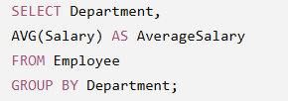

7. Sample Employee Table
EmpID | Name | Department | Salary
1 | Ram | HR | 30000
2 | Asha | HR | 40000
3 | John | IT | 60000
4 | Priya | IT | 70000
5 | David | Sales | 50000

8. Output
Department | AverageSalary
HR | 35000
IT | 65000
Sales | 50000

9. Explanation
GROUP BY Department
Groups employees according to department.
AVG(Salary)
Calculates average salary within each department.
AS AverageSalary
Renames the output column.

10. Working Process

Employee Table

↓

GROUP BY Department

↓

HR Group
30000
40000

↓

Average = 35000

↓

IT Group
60000
70000

↓

Average = 65000

↓

Sales Group
50000

↓

Average = 50000

11. Advantages of GROUP BY
- Produces summarized reports.
- Simplifies data analysis.
- Improves readability.
- Useful in business intelligence.
- Supports statistical calculations.

12. Real-Life Applications
- Department-wise salary report.
- Product-wise sales report.
- Student-wise average marks.
- Branch-wise bank transactions.
- Monthly revenue analysis.

13. Common Errors
- Forgetting GROUP BY.
- Misspelling column names.
- Using aggregate functions in WHERE instead of HAVING.
- Incorrect grouping.

15. Conclusion
Aggregate functions summarize data, while GROUP BY organizes rows into meaningful groups. Correct usage enables accurate reporting, improves query performance, and supports effective business decision-making.

Q3. Correct a Faulty SELECT Query Where Column Names Are Misspelled or Improperly Referenced

1. Introduction
The SELECT statement is the most frequently used SQL command. It retrieves data from one or more tables. If column names are misspelled or incorrectly referenced, SQL cannot find the required column and returns an error.
Understanding how to identify and correct such errors is essential for writing reliable SQL queries.

2. SELECT Statement
The SELECT statement retrieves data from database tables.
Syntax
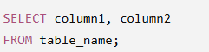

3. Incorrect Query


4. Error Identification
The column name StudntName is incorrect.
Correct column name:

5. Correct Query
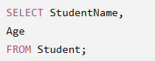

6. Sample Student Table
StudentID | StudentName | Age
101 | Asha | 20
102 | Rahul | 21
103 | Priya | 22
7. Output
StudentName | Age
Asha | 20
Rahul | 21
Priya | 22

8. Explanation
SELECT
Retrieves specified columns.
StudentName
Displays student names.
Age
Displays age.
FROM Student
Specifies the source table.

9. Other Common Errors
Wrong Table Name

Correct:
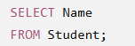

Missing Comma
Incorrect

Correct
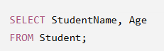

Invalid Alias
Incorrect
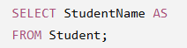

Correct


10. Advantages of Correct Queries
- Faster execution.
- Accurate results.
- Prevents runtime errors.
- Easy to maintain.
- Improves readability.

11. Real-Life Applications
- Student information systems.
- Banking databases.
- Hospital records.
- E-commerce product lists.
- Employee management systems.
- Library databases.

12. Common SQL Errors
- Misspelled column names.
- Wrong table names.
- Missing commas.
- Incorrect aliases.
- Case-sensitive object names (in some DBMSs).

14. Conclusion
The SELECT statement is fundamental to SQL. Correct column references, proper syntax, and accurate table names ensure successful data retrieval. Identifying and fixing errors improves query reliability, enhances database performance, and is an essential skill for database developers and administrators.

Q4. Fix Errors in an SQL Query Using JOIN Where the Join Condition is Missing or Incorrect

1. Introduction
A JOIN is an SQL operation used to combine data from two or more tables based on a common column. It helps retrieve related information stored in different tables without duplicating data. If the join condition is missing or incorrect, SQL may return incorrect results, duplicate rows, or a Cartesian Product.

2. Definition of JOIN
A JOIN combines rows from two or more tables using a common field.
General Syntax
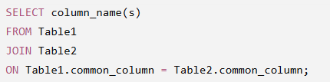

3. Types of SQL JOIN
- INNER JOIN
- LEFT JOIN
- RIGHT JOIN
- FULL OUTER JOIN
- CROSS JOIN
- SELF JOIN

4. Sample Tables
Student Table
StudentID | StudentName | DepartmentID
101 | Rahul | D01
102 | Priya | D02
103 | Asha | D01

DepartmentID | DepartmentName
D01 | Computer Science
D02 | Electronics

5. Incorrect SQL Query



6. Error Identification
Error 1
Missing ON clause.
Error 2
No relationship is specified between the tables.
Error 3
Produces a Cartesian Product, where every student is matched with every department.

7.Correct SQL Query
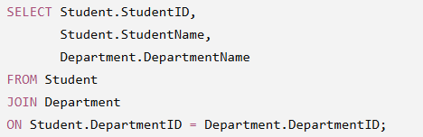

8. Explanation
SELECT
Retrieves required columns.
FROM Student
Specifies the first table.
JOIN Department
Joins the Department table.
ON Student.DepartmentID = Department.DepartmentID
Matches students with their respective departments.

9. Expected Output
StudentID | StudentName | DepartmentName
101 | Rahul | Computer Science
102 | Priya | Electronics
103 | Asha | Computer Science
10. Cartesian Product (Incorrect Result)
Without the ON clause:
Student | Department
Rahul | Computer Science
Rahul | Electronics
Priya | Computer Science
Priya | Electronics
Asha | Computer Science
Asha | Electronics
This incorrect result contains unnecessary combinations.
11. Advantages of Using JOIN
- Combines related data from multiple tables.
- Reduces data redundancy.
- Improves database normalization.
- Produces meaningful reports.
- Makes querying efficient.

12. Real-Life Applications
- Student–Department databases.
- Customer–Order systems.
- Employee–Department management.
- Hospital patient records.
- Banking account management.
- E-commerce order processing.

13. Common JOIN Errors
- Missing ON clause.
- Wrong join column.
- Joining unrelated tables.
- Selecting ambiguous column names.
- Using incorrect JOIN type.

15. Conclusion
JOIN is an essential SQL feature for retrieving related information from multiple tables. Specifying the correct join condition ensures accurate results, eliminates unnecessary records, and improves query efficiency.

Q5. Identify and Correct a Subquery Error Where Multiple Values are Returned Instead of a Single Value

1. Introduction
A subquery (nested query) is an SQL query written inside another SQL query. The inner query executes first, and its result is used by the outer query.
Errors occur when a subquery returns multiple rows but the outer query expects only one value.

2. Definition of Subquery
A subquery is a query placed inside another SQL statement.
Syntax
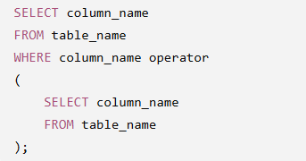

3. Types of Subqueries
- Single-row subquery
- Multiple-row subquery
- Multiple-column subquery
- Correlated subquery
- Nested subquery

4. Sample Employee Table
EmpID | Name | Department | Salary
101 | Ram | IT | 60000
102 | John | IT | 50000
103 | Asha | HR | 50000
104 | Priya | Sales | 45000

5. Incorrect SQL Query
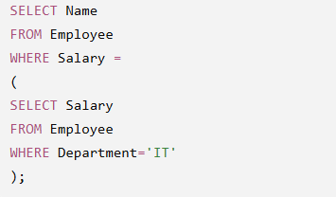
6. Error Identification
The inner query returns:
60000
50000
Since two values are returned, the "=" operator cannot compare one value with multiple values.
SQL displays an error similar to:

7.Correct Method 1 (Using IN)
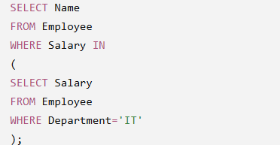

8. Output
Name
Ram
John
Asha
(Asha has salary 50000, which matches one of the IT salaries.)

9. Correct Method 2 (Using MAX)
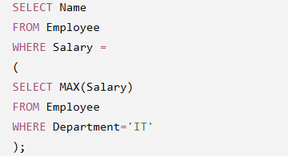

10. Output
Name
Ram

11. Explanation
"=" Operator
Used only when the subquery returns one value.
IN Operator
Used when multiple values are returned.
MAX()
Converts multiple rows into one value.

12. Advantages of Subqueries
- Simplifies complex queries.
- Improves readability.
- Avoids temporary tables.
- Retrieves dynamic data.
- Supports nested calculations.

13. Applications
- Highest-paid employee.
- Students scoring above average.
- Product price comparisons.
- Banking transaction analysis.
- Hospital patient reports.

14. Common Errors
- Using "=" for multiple rows.
- Missing parentheses.
- Incorrect column references.
- Returning multiple columns instead of one.
- Wrong aggregate function usage.

16. Conclusion
Subqueries are powerful tools for solving complex SQL problems. Choosing the correct operator, such as IN for multiple values or aggregate functions for a single value, ensures error-free execution and accurate results.

Q6. Debug a VIEW Creation Statement That Contains Invalid Column References or Syntax Errors

1. Introduction
A VIEW is a virtual table created from one or more database tables. It stores only the SQL query and displays data whenever it is accessed. Views improve security, simplify complex queries, and provide customized data to users.

2. Definition of VIEW
A VIEW is a virtual table based on the result of an SQL query.
Syntax
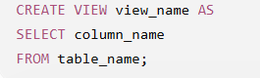

3. Advantages of VIEW
- Improves security.
- Hides sensitive columns.
- Simplifies complex SQL queries.
- Reduces query repetition.
- Provides customized data access.

4. Sample Student Table
StudentID | StudentName | Age | Department
101 | Rahul | 20 | CSE
102 | Priya | 21 | ECE
103 | Asha | 22 | CSE

5. Incorrect VIEW Statement
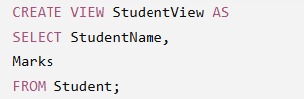

6. Error Identification
Error 1
Column Marks does not exist in the Student table.
Error 2
SQL cannot create a view with invalid column references.
Typical error message:

7. Correct VIEW Statement
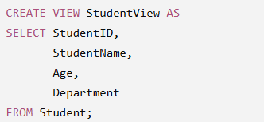

8. Viewing the Data


9. Output
StudentID | StudentName | Age | Department
101 | Rahul | 20 | CSE
102 | Priya | 21 | ECE
103 | Asha | 22 | CSE

10. Explanation
CREATE VIEW
Creates a virtual table.
SELECT
Chooses the required columns.
FROM Student
Specifies the source table.
Only existing columns can be included in the view.

11. Applications of VIEW
- Employee salary reports.
- Student information systems.
- Banking account summaries.
- Hospital patient records.
- E-commerce order reports.
- College administration.

12. Common Errors in VIEW Creation
- Invalid column names.
- Incorrect table names.
- Missing SELECT statement.
- Syntax errors.
- Missing permissions.
- Duplicate view names.

13. Advantages of Using VIEW
- Enhances data security.
- Simplifies complex SQL statements.
- Hides unnecessary columns.
- Supports data abstraction.
- Makes reporting easier.

14. Conclusion
Views provide a secure and efficient way to access database information without exposing the underlying tables. Ensuring that all referenced columns exist and that the SQL syntax is correct prevents view creation errors and improves database usability.

Q7. Examine an SQL Query with Unnecessary Conditions and Optimize it by Simplifying the WHERE Clause

1. Introduction
Query optimization is the process of improving the performance and efficiency of SQL queries. An optimized query retrieves the required data using fewer resources and executes faster. One common optimization technique is removing unnecessary or redundant conditions from the WHERE clause.
A simplified query is easier to understand, maintain, and execute while producing the same result.

2. Definition of Query Optimization
Query Optimization is the process of selecting the most efficient method of executing an SQL query to reduce execution time and improve database performance.

3. Purpose of the WHERE Clause
The WHERE clause filters rows based on specified conditions.
Syntax
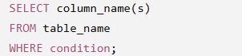
4. Incorrect SQL Query
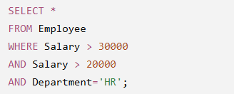
5. Error Identification
Error 1
The condition:
Salary > 20000
is unnecessary because:
Salary > 30000
already includes all salaries greater than 20,000.
Error 2
Redundant conditions increase query complexity and may slightly affect performance.

6. Correct SQL Query
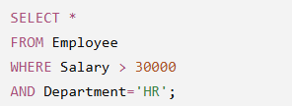
7. Sample Employee Table
EmpID | Name | Department | Salary
101 | Rahul | HR | 35000
102 | Priya | HR | 28000
103 | John | IT | 45000
104 | Asha | HR | 50000
105 | David | Sales | 38000
8. Output
EmpID | Name | Department | Salary
101 | Rahul | HR | 35000
104 | Asha | HR | 50000

9. Explanation
Salary > 30000
Retrieves employees earning more than ₹30,000.
Department='HR'
Filters only HR department employees.
Combined Condition
Returns only HR employees whose salary exceeds ₹30,000.

10. Query Optimization Techniques
- Remove redundant conditions.
- Select only required columns instead of using SELECT *.
- Use indexes on frequently searched columns.
- Avoid unnecessary subqueries.
- Use proper JOIN conditions.
- Filter records as early as possible.
- Use EXISTS instead of IN for large datasets where appropriate.

11. Benefits of Query Optimization
- Faster execution.
- Lower CPU usage.
- Reduced memory consumption.
- Efficient database performance.
- Better scalability.
- Faster report generation.

12. Real-Life Applications
- Banking transaction systems.
- Employee payroll.
- Student databases.
- Hospital management.
- Online shopping websites.
- Railway reservation systems.

13. Common Optimization Mistakes
- Using redundant conditions.
- Using SELECT * unnecessarily.
- Missing indexes.
- Unnecessary nested queries.
- Incorrect JOIN conditions.
- Functions on indexed columns in WHERE clause.

15. Conclusion
Query optimization improves SQL performance by eliminating unnecessary conditions and simplifying queries. Efficient SQL queries consume fewer system resources, execute faster, and enhance overall database performance.

Q8. Identify Violations of Integrity Constraints in a Given Table and Correct Them

1. Introduction
Integrity constraints are rules applied to database tables to maintain the accuracy, consistency, and reliability of data. They prevent invalid data entry and ensure relationships between tables remain correct.
If integrity constraints are violated, the database may contain duplicate, incomplete, or inconsistent records.

2. Definition of Integrity Constraints
Integrity constraints are rules enforced by the DBMS to ensure only valid and consistent data is stored in a database.

3. Types of Integrity Constraints
1. Primary Key Constraint
- Uniquely identifies each record.
- Cannot contain NULL values.
- No duplicate values allowed.
2. Foreign Key Constraint
- Maintains relationships between tables.
- Prevents invalid references.
3. NOT NULL Constraint
- Prevents NULL values.
4. UNIQUE Constraint
- Prevents duplicate values.
5. CHECK Constraint
- Restricts values based on a condition.
6. DEFAULT Constraint
- Assigns a default value when none is provided.

4. Sample Table with Violations
StudentID | StudentName | Email | Age
101 | Rahul | rahul@gmail.com | 20
101 | Priya | priya@gmail.com | 21
NULL | Asha | asha@gmail.com | 22
104 | David | rahul@gmail.com | 17

5. Error Identification
Error 1 – Duplicate Primary Key
StudentID 101 appears twice.
Violation:
- PRIMARY KEY constraint.

Error 2 – NULL Primary Key
StudentID cannot be NULL.
Violation:
- NOT NULL constraint.

Error 3 – Duplicate Email
Two students have the same email.
Violation:
- UNIQUE constraint.

Error 4 – Invalid Age
Suppose the rule is:
CHECK (Age >= 18)
Age 17 violates the CHECK constraint.

6. Correct Table
StudentID | StudentName | Email | Age
101 | Rahul | rahul@gmail.com | 20
102 | Priya | priya@gmail.com | 21
103 | Asha | asha@gmail.com | 22
104 | David | david@gmail.com | 19

7. SQL Statement with Constraints
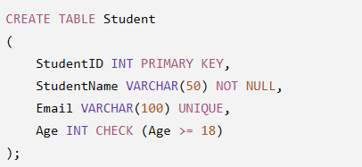
8. Explanation
PRIMARY KEY
Ensures every StudentID is unique.
NOT NULL
Ensures StudentName is always entered.
UNIQUE
Ensures no two students have the same email.
CHECK
Ensures only students aged 18 or above are stored.

9. Advantages of Integrity Constraints
- Prevent duplicate records.
- Maintain accurate data.
- Improve data consistency.
- Enforce business rules.
- Maintain relationships between tables.
- Reduce data entry errors.

10. Real-Life Applications
- Banking systems.
- Hospital databases.
- University management.
- Railway reservation.
- Library management.
- Online shopping websites.

11. Consequences of Constraint Violations
- Duplicate records.
- Incorrect reports.
- Loss of data consistency.
- Invalid relationships.
- Difficulty in database maintenance.
- Increased chances of application errors.

12. Best Practices
- Always define a Primary Key.
- Use Foreign Keys for related tables.
- Apply CHECK constraints for validation.
- Avoid unnecessary NULL values.
- Use UNIQUE for important fields like email or phone number.

14. Conclusion
Integrity constraints are essential for maintaining the quality, consistency, and reliability of database systems. By enforcing rules such as PRIMARY KEY, FOREIGN KEY, NOT NULL, UNIQUE, and CHECK, organizations can prevent invalid data entry, reduce errors, and ensure efficient database management. Proper use of integrity constraints is a fundamental practice in designing secure and reliable relational databases.

Q9. Fix a Relation that Violates 1NF or 2NF by Removing Repeating Groups or Partial Dependencies

1. Introduction
Normalization is the process of organizing data in a database to reduce redundancy and improve data integrity. It divides large tables into smaller, related tables while maintaining relationships between them. The first two stages of normalization are First Normal Form (1NF) and Second Normal Form (2NF).
Normalization prevents data anomalies and improves database efficiency.

2. Definition of Normalization
Normalization is a database design technique used to eliminate redundant data and ensure data dependencies are logical.

3. Objectives of Normalization
- Eliminate duplicate data.
- Improve data consistency.
- Reduce storage space.
- Avoid insertion, update, and deletion anomalies.
- Improve database performance.

4. Normal Forms
First Normal Form (1NF)
- Each column contains only atomic (single) values.
- No repeating groups.
- Each row is unique.
Second Normal Form (2NF)
- Table must already be in 1NF.
- Removes partial dependency.
- Every non-key attribute depends on the entire primary key.

5. Unnormalized Relation (UNF)
StudentID | StudentName | Subjects
101 | Rahul | DBMS, Java
102 | Priya | Python, CN
Problem
The Subjects column contains multiple values.
This violates 1NF because one attribute should contain only one value.

6. Convert to First Normal Form (1NF)
StudentID | StudentName | Subject
101 | Rahul | DBMS
101 | Rahul | Java
102 | Priya | Python
102 | Priya | CN
Explanation
- Each cell contains only one value.
- Repeating groups are removed.
- Data becomes easier to query.

7. Convert to Second Normal Form (2NF)
Student Table
StudentID | StudentName
101 | Rahul
102 | Priya
Enrollment Table
StudentID | Subject
101 | DBMS
101 | Java
102 | Python
102 | CN
Explanation
StudentName depends only on StudentID, not on Subject. Therefore, StudentName is separated into another table.

8. SQL Statements
Student Table
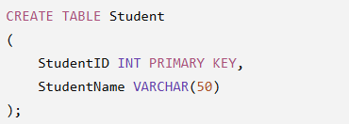

Enrollment Table
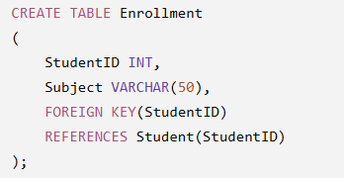

9. Advantages of 1NF and 2NF
- Eliminates duplicate data.
- Improves consistency.
- Reduces storage requirements.
- Prevents update anomalies.
- Easier database maintenance.
- Improves query performance.

10. Data Anomalies Prevented
Insertion Anomaly
Cannot insert unnecessary duplicate information.
Update Anomaly
Updating data in one place automatically maintains consistency.
Deletion Anomaly
Deleting one record does not remove unrelated information.

11. Applications
- College Management System
- Hospital Database
- Banking System
- Railway Reservation
- Library Management
- Employee Database

13. Conclusion
Normalization improves the quality of database design by eliminating redundancy and ensuring data integrity. Converting a relation into 1NF removes repeating groups, while 2NF removes partial dependencies, making the database efficient, consistent, and easier to maintain.

Q10. Identify Redundant Attributes in a Relation and Apply Normalization (Up to 3NF) to Improve Database Design

1. Introduction
A well-designed database minimizes redundant data and stores information efficiently. Third Normal Form (3NF) removes transitive dependencies, where one non-key attribute depends on another non-key attribute instead of the primary key.
Applying normalization up to 3NF improves database consistency, reduces duplication, and simplifies maintenance.

2. Definition of Third Normal Form (3NF)
A relation is in Third Normal Form (3NF) if:
- It is already in Second Normal Form (2NF).
- There are no transitive dependencies.
- Every non-key attribute depends only on the primary key.

3. Original Relation
StudentID | StudentName | DeptID | DeptName | HOD
101 | Rahul | D01 | Computer Science | Dr. Rao
102 | Priya | D02 | Electronics | Dr. Kumar
103 | Asha | D01 | Computer Science | Dr. Rao

4. Redundant Attributes
The following attributes are repeated for every student in the same department:
- DeptName
- HOD
This causes data redundancy.

5. Problems Caused by Redundancy
- Wastes storage space.
- Difficult to update department information.
- Increased chances of inconsistent data.
- Slower database performance.

6. First Normal Form (1NF)
The relation already satisfies 1NF because all values are atomic.

7. Second Normal Form (2NF)
Since StudentID is the primary key, every non-key attribute depends on it.
However, DeptName and HOD depend on DeptID rather than StudentID.

8. Third Normal Form (3NF)
Student Table
StudentID | StudentName | DeptID
101 | Rahul | D01
102 | Priya | D02
103 | Asha | D01

Department Table
DeptID | DeptName | HOD
D01 | Computer Science | Dr. Rao
D02 | Electronics | Dr. Kumar

9. SQL Statements
Department Table
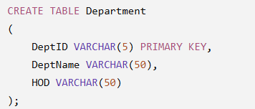

Student Table

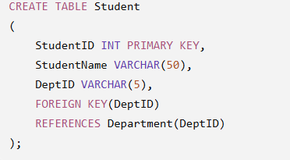

10. Advantages of 3NF
- Eliminates transitive dependency.
- Removes redundant data.
- Improves consistency.
- Saves storage space.
- Simplifies updates.
- Prevents anomalies.
- Improves database performance.

12. Applications
- University databases
- Banking systems
- Hospital management
- Railway reservation
- Inventory management
- Employee management
- Library management
- Online shopping systems

13. Comparison of Normal Forms
Normal Form | Purpose | Removes
1NF | Atomic values | Repeating groups
2NF | Full dependency | Partial dependency
3NF | No transitive dependency | Redundant attributes

15. Conclusion
Normalization up to Third Normal Form (3NF) creates an efficient and well-structured database by removing redundant attributes and transitive dependencies. It improves data integrity, minimizes storage requirements, prevents insertion, update, and deletion anomalies, and enhances database performance. Proper normalization is a fundamental practice in designing reliable and scalable relational database systems suitable for real-world applications.

